

Shipley Do-Nuts: Knowledge Base

Troubleshooting for common issues

A Step – by - Step Guide
Password reset on NCR
Scenario: FC is calling because they forgot the password to their NCR account.

- Access to NCR Homepage .
- Enter the email address provided by the FC and click PASSWORD.

“Could you please provide me with your NCR email?" Wait for a response. Once you receive it,
repeat the email address back to the customer to ensure it is correct.
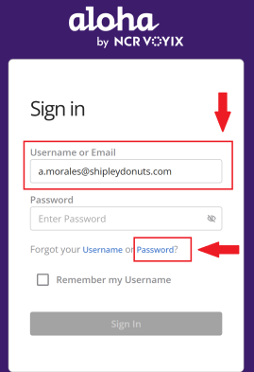

- A pop-up will appear, prompting you to enter the email address to which the reset link should be sent.
- Enter the email address and click RESET.
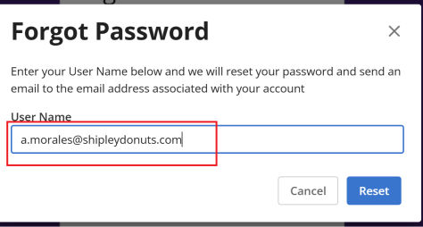

"A password reset link has been sent to your email. If you cannot see the email in your inbox, please check your spam folder”. [Advise the FC to follow the instructions in the email to reset their password. Optional: Suggest setting a password that is easier to remember.]

